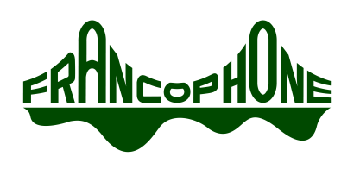
AGENDA
Francophone Charter School of Oakland
Board of Directors Special Meeting
9736 Lawlor Street, Oakland, CA
Thursday, March 17, 2016 at 10:00pm

Opening Items
  - Call to Order
Meeting was called to order at _________________.
  - Roll Call
  - Approval of Agenda

PUBLIC COMMENT
Non-agenda items: Public comments on non-agenda items shall be made at the end of the Board meeting. No individual presentation shall be for more than 2 minutes and the total time for this purpose shall not exceed twenty (20) minutes. Ordinarily, Board members will not respond to presentations and no action can be taken.
Agenda items: Please add your name to the “request to speak” form if you would like to speak on an agendized item. When that item comes up, you will be asked to stand, state your name for the record and make your presentation. No individual presentation shall be for more than 3 minutes.
The full public comment policy is available in the Board meeting binder.

Action and Discussion Items

Agenda Item | Time | Status*
- Administrative Training | 10:00PM | Red
- Safety Plans | 10:10PM | Yellow

ADJOURN
The meeting was adjourned at ______________.

