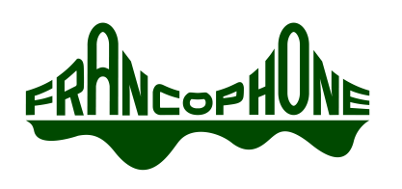
Agenda
Governance Committee
Francophone Charter School of Oakland
Location:
3200 Revere Ave. Oakland, CA 94605
Thursday January 9, 2020
8:30AM-10AM

Opening Items
  - Call to Order:
  - Roll Call
Committee Member Name | Present | Absent
Annette Dennett
Jean Johnstone
Erin O’Donohue
Kirk Anne Taylor
David Phillips

Guests: Mark Kushner

  - Approval of Agenda

Public Comment

Non-agenda items: Public comments on non-agenda items shall be made at the beginning of the Board meeting. No individual presentation shall be for more than 2 minutes and the total time for this purpose shall not exceed twenty (20) minutes. Ordinarily, Board members will not respond to presentations and no action can be taken.

Agenda items: Please add your name to the “request to speak” form if you would like to speak on an agendized item. When that item comes up, you will be asked to stand, state your name for the record and make your presentation. No individual presentation shall be for more than 3 minutes.
The full public comment policy is available in the Board meeting binder.

Action & Discussion Items

Agenda Item | Purpose | Who | Time
Approval of 12/5/19 minutes | Approve | All | 5
Board retreat | Discuss | David | 15
Board self-assessment | Discuss | Kirk Anne | 15
Board recordkeeping, inc. Board on Track integration | Discuss | All | 10
Recruitment | Discuss | All | 15
Legal compliance | Discuss | Erin | 5
Suicide Prevention Policy | Discuss | Annette | 5

Adjourn

