School Reopening Plan

Name of School: Francophone Charter School of Oakland

Address: 9736 Lawlor Street, Oakland, CA 94605 (Toler Heights campus: 3 – 8)
2634 Pleasant St, Oakland, CA 94602 (St. Jarlath campus: K – 2)

Executive Director: Kennedy Hilario, kennedy@francophoneschool.org

School Type: Charter

Date of Reopening: August 18, 2021

Date of Posting of Reopening Plan: June 25, 2021

COVID-19 Liaison: Kennedy Hilario

Grade Levels Served: K-8

Grades Reopening: K-8

Number of Students Returning: 146

Number of Students Distance Learning: 148

Number of Staff Returning: 16

This plan is posted on the school website.

Please complete the following Survey to confirm that you have read the School Reopening Plans - COVID and that you agree to comply with the protocols stated here and that you will do a DAILY health screening with your student prior to arrival at school.

Introduction

The Francophone Charter School of Oakland has been monitoring COVID-19 guidance by the State of California, the California Department of Public Health (CDPH), the California Department of Education (CDE), the Alameda County Public Health Department (ACPHD), the Alameda County Office of Education (ACOE), and the Oakland Unified School District (OUSD). In order to reopen our school to students and staff, this COVID-19 Reopening Plan has been prepared, and modifications within this document made to school facilities, to support as safe an environment as possible for all people on campus, including learners, teachers, staff and volunteers. This plan includes best practices and guidance issued by the aforementioned government entities and strives to prevent the spread of COVID-19 amongst its cohorts.

While the modifications and rules required for in-person learning will present some challenges, we know in-person instruction is critical for children to learn and build social and emotional connections. We are committed to making these adjustments to provide a safe environment of focused learning.

Below is a list of items that will be addressed, per guidance, by our school as we prepare to welcome students back in a staggered manner, starting with one section each of Kindergarten, 1st grade, and 2nd grade. Each grade level will be welcomed on campus on a regular schedule for five days a week with its entire grade cohort for regular instruction.

- Cleaning, Disinfection and Ventilation
  - Cleaning and Disinfection:
    - Regular cleaning of shared surfaces to include shared desks, light switches, door knobs, countertops, keyboards, and phones, will be done daily by staff on an as needed basis.
    - Prior to leaving class at the end of the school day, students will wipe down desks with a baby wipe.
    - Bathrooms and high touch surfaces will be cleaned and disinfected by janitorial staff each day that there are students on campus.
    - Cafeteria space (if used) will be cleaned after lunch by staff and disinfected by janitorial staff each day.
    - Disinfectant products used by the janitorial staff will be EPA approved from this list: link
    - A NOTE ON DISINFECTION FROM THE GUIDANCE: “Frequent disinfection, which was thought at the beginning of the pandemic to be a key safety component, can pose a health risk to children and students due to the chemicals used and has proven to have limited to no impact on COVID- 19 transmission. Disinfection with specified products, is recommended for schools after a case has been identified in the school, in the spaces where the case spent a large proportion of their time (e.g., classroom, or administrator’s office if an administrator). Please see Cleaning and Disinfection section for additional details.” Link to guidance

  - Ventilation
    - Our campuses do not have forced air HVAC (Heating Ventilation Air Conditioning) systems and all classrooms have windows that open to provide for maximum ventilation throughout the school.
    - We will increase ventilation through open windows, doors and use outdoor spaces as much as possible to increase dispersion of aerosols and droplets.
    - We have purchased child-safe fans to increase ventilation within the classroom – facing fans outward to help eliminate indoor air.
    - Ceiling fans have been reversed to help suck air towards the ceiling and disperse inside air out towards the open windows to promote fresh air circulation.
    - The school has purchased 29 Wynd brand Max Room Air Purifiers with HEPA filters that can clean a 1,200 square foot space in under 30 minutes, adding valuable filtration of particles as small as viral aerosols, but also including allergens, dust, smoke and other air pollutants that our children may be exposed to on a daily basis. These will be placed in classrooms, common spaces such as the office and in hallways.
- Cohorts – All grades and students are coming back since we are relaxing the 6 foot distance criteria.

- Physical distancing
  - Desks will be spaced within the classroom to maintain a distance of at least 3 feet between students and at least 3 feet between students and teacher or other adults.
  - To the extent practicable, a distance of 3 feet will be maintained when moving throughout the facilities and during outdoor time/recess and lunch.

- Entrance, Egress and movement within the school
  - Morning drop-off and afternoon pick-up plans are outlined in Addendum #1. Please note that the plans for the two campuses are not identical. For all campuses: Please try to arrive during the rolling drop-off time window. Late arrivals must be dropped (accompanied by an adult) to the school office and checked in. If your child is more than 30 minutes late 3 times for reasons other than medical appointments or family emergencies, you will be contacted by the leadership to discuss solutions on how to avoid late arrivals.
  - Once your child’s temperature has been taken and is below 100° F, they will directly go to the restroom where they will wash their hands with soap and water before entering the classroom.

- Face coverings and protective gear
  - All students, staff and visitors MUST wear well-fitted face masks, worn properly (covering both mouth and nose) on campus at all times unless they are exempt by guidance provided by CDPH found here. If a student is exempt, the family must consult with school administration prior to arriving on campus so that alternative compliant arrangements may be made and communicated to teachers and staff. Only with staff permission and substantial social distancing can masks be removed for eating or drinking.
  - Please see the attached Addendum #2 on mask guidance to find the best mask for your student.
  - For guidance on mask use, removal and washing – see CDC link here. Cloth masks should be washed daily.
  - The school will have available an ample supply of PPE for staff use and student use as necessary, but to the greatest extent possible, please provide a comfortable, size appropriate and clean mask for your child.
  - Please include a clean mask in a plastic bag labeled with your child’s name on it in their backpack. This will allow students to swap masks if they get dirty, broken or wet throughout the day.

- Health Screenings/ Testing –
  - Staff and families are to review daily (before coming to school) the COVID-19 Health Screening (see Addendum #3) with a list of COVID-19 symptoms and questions that you should review with your child prior to leaving for school each morning.
  - Please check your child for symptoms prior to arriving at school. Please do not bring your child if they have any symptoms or if anyone in your household has been in contact with or exposed to a COVID-19 positive person per the screening document. Your child’s temperature will be taken at the school with a non-contact thermometer and any child with a temperature higher than 100° F (37.8° C) will not be allowed to enter the school.
  - Any child or staff with any Covid-19 symptoms must stay home.
  - If a student, staff or visitor begins to feel ill or exhibit one or more symptoms of COVID-19 during their time on campus, they will be immediately isolated (if it is a child, they will be supervised in a room separated from other children), and parents will be called and asked to pick up their child ASAP, within 30 minutes or fewer for the safety of the student and the community.

- Hygiene practices
  - Hand washing and/or hand sanitizing will be required on a regular basis during the school day upon entering the school, prior to and after recess, lunch, and bathroom breaks.
  - Ethyl alcohol based hand sanitizer will be made available for student and staff use when hand washing is not practical.
  - Teachers will teach students to use tissues to wipe noses and to cough/sneeze into a tissue or their elbow.
  - The school has procured adequate amounts of soap, paper towels, hand sanitizer and tissues to support these higher frequency hygiene practices.

- Identification and Tracing of Contacts
  - If a student or staff member develops symptoms while at school, they will be immediately isolated and sent home. Students and staff then must meet CDPH criteria to return:
    - At least 24 hours have passed since resolution of fever without the use of fever-reducing medications; and
    - Other symptoms have improved; and
    - They have a negative test for SARS-CoV-2, OR a healthcare provider has provided documentation that the symptoms are typical of their underlying chronic condition (e.g., allergies or asthma) OR a healthcare provider has confirmed an alternative named diagnosis (e.g., Streptococcal pharyngitis, Coxsackie virus), OR at least 10 days have passed since symptom onset.
  - If the school learns of a confirmed case of COVID-19 within the school community (to include staff, students, parents or other volunteers), the school will immediately notify the affected cohort and follow the protocol laid out in Addendum #4 per CDPH guidelines.
  - The Executive Director will serve as both the school site liaison to contact tracing within the school and as the COVID liaison to work with the local health department to assist with contact tracing.

- Staff and family training, education and engagement
  - Prior to reopening the school this plan, staff and families were given a draft copy of this document, time to read it and were given an opportunity to provide feedback, engage with the school leadership and ask questions and get clarifications.
  - Staff received training about this document, guidance documents, best practices in prevention, Cal/OSHA requirements and protections.
    - Staff engagement session will take place on Wednesday, March 24 at 3:30pm
  - Parents and guardians received two opportunities to engage directly to answer questions and sign off to acknowledge receipt and agree to support the school in adherence to safety measures and protocols put in place to prevent the spread of COVID-19.
  - Two parent/family engagement sessions are available.
    - The first on Tuesday, March 23 at 6:00pm and the second on Wednesday, March 24 at 10:30am
    - Communication with this plan as well as other required documents went out through ParentSquare, our school’s primary communication tool, on Friday, March 19 to all families and staff
    - In the event that parents are not able to attend engagement sessions, they are encouraged to reach out to leadership with any questions or concerns.
  - Once school begins, students will spend time learning the new rules and protocols put forth in this document to keep their fellow students and school staff safe.
  - As always school leadership remains available for questions at any time about COVID-19 safety related questions and any other questions that families may have via ParentSquare or email kennedy@francophoneschool.org.

- Triggers for pausing in-person programming and returning to distance learning are as follows. These may take place for a length of 14 days or another period of time determined in consultation with the Local Health Department (LHD), the Alameda County Department of Public Health (ACDPH).
  - Within a 14-day period, an outbreak (3 or more confirmed or probable cases of staff or students occurring within a 14-day period who are epidemiologically linked in the school, are from different households and are not contacts of each other in any other investigation cases (e.g., transmission likely occurred in the school setting) has occurred in 25% or more stable groups in the school.
  - Within a 14-day period, at least three outbreaks have occurred in the school AND more than 5% of the school population is infected.
  - The Alameda County Department of Public Health may also determine school closure is warranted for other reasons, including results from public health investigation or other local epidemiological data.

- Communication Plan
  - We will follow HIPAA and FERPA requirements of privacy.
  - Form letters – we will use Appendix 2: Sample Notifications from the CDPH guidance to inform staff and/or families of a suspected or confirmed case of COVID (See addendum #5, #6 and #7).
  - We will continue to update families and staff of any changes to school protocol as guidance changes or as the county moves into different tiers.
  - We are dedicated to radical transparency amongst our community to ensure the safety of all stakeholders and will continue to accommodate families who prefer to remain in distance learning throughout the remainder of this 2020/2021 school year.

Parent/Guardian agreement survey - Please click this link to fill out a survey stating you have read this document and will support the school’s efforts to protect the health and safety of the school community.

Addendum #1
Drop-Off & Pick-Up: St. Jarlath Campus (Grades K-2)

Drop-Off & Pick-Up Procedures for St. Jarlath Campus (Grades K-2)

Francophone Charter School’s St. Jarlath Campus encourages students and families to consider and use multiple forms of transportation to travel to and from school. We have designed the following drop-off and pick up procedures to ensure that students can safely and efficiently access and exit the campus at the start and end of each school day:
- Rolling Drop-Off (AM Drop-Off Only)
- Park and Walk (AM Drop-Off and ALL PM Pick-Ups)

Drop Off and Pick Up Times and Location

- St. Jarlath Campus drop off times are from 8: 00am – 8:15am
- St. Jarlath Campus pick-up times are from 2:30am – 3:00pm
- AM Rolling Drop-Off is open and available to families between 8:30am – 9:00am. After this time period gates will be locked and families must use Francophone’s Park and Walk Procedures.
- During campus drop off and pick up times, campus gates will be unlocked and open for all students and families using the park and walk option.
- Outside of the campus drop-off and pick-up times, campus gates will be closed and locked. During these times, parents/guardians are to escort students to the St. Jarlath campus entrance on Pleasant Street and check the student in at the office.
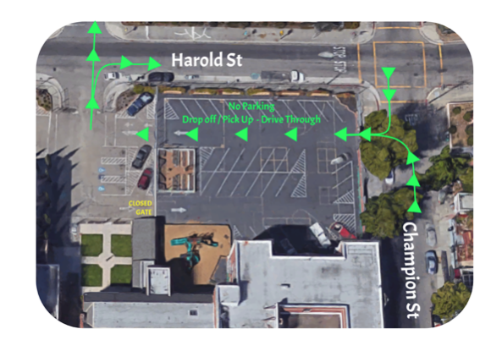

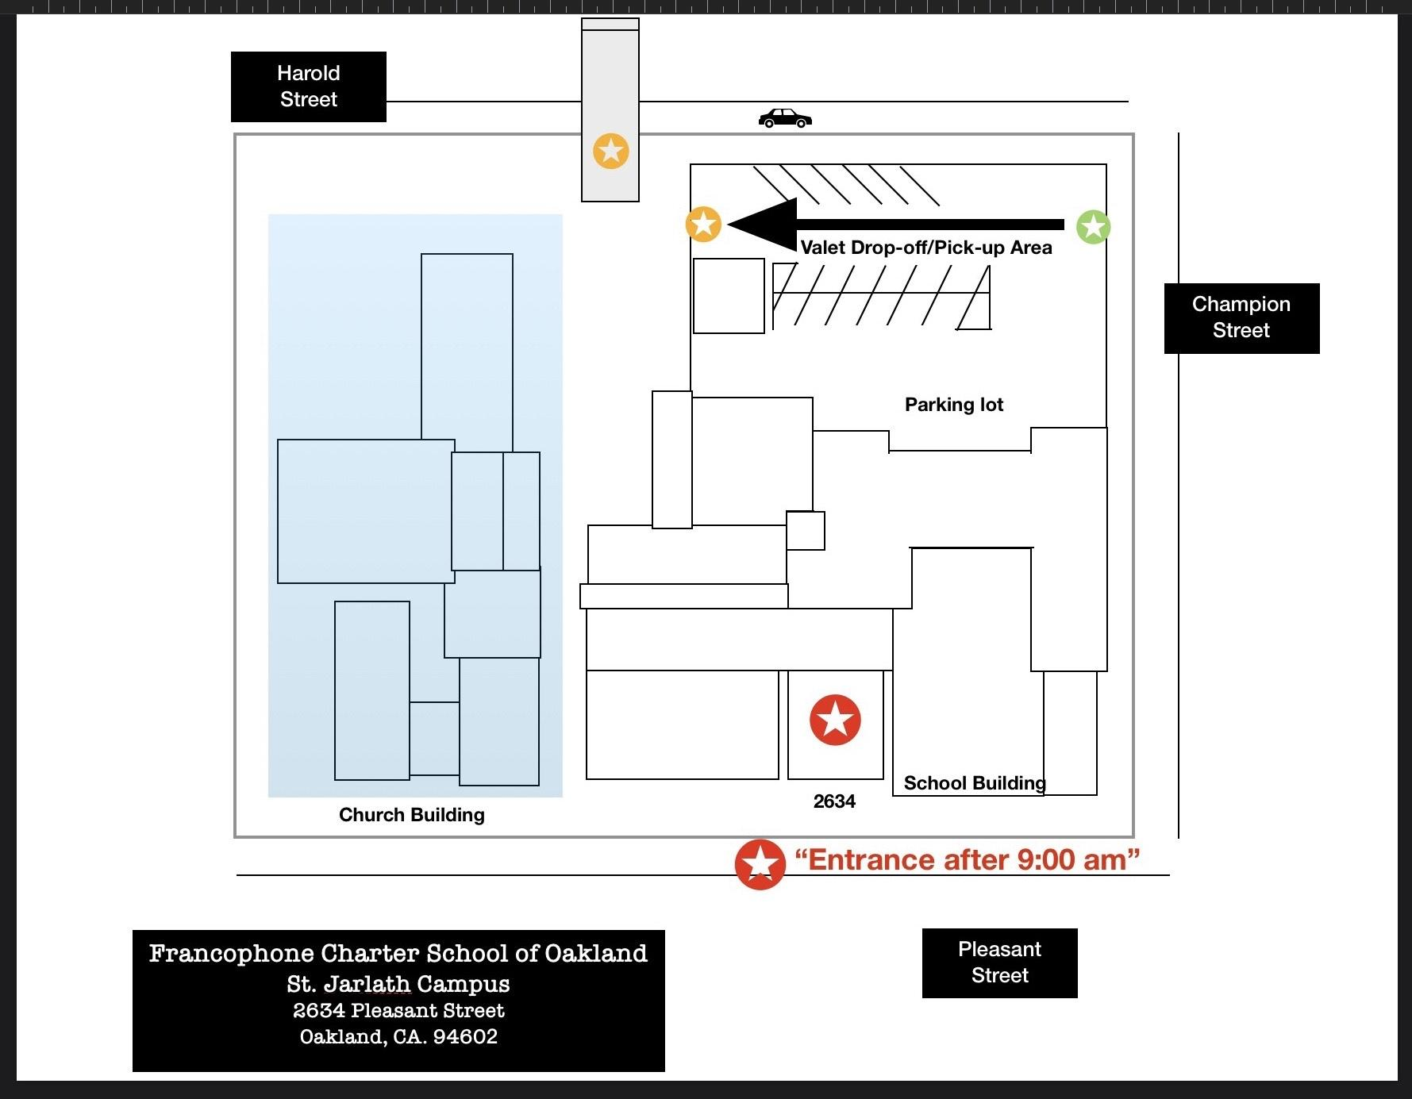

Rolling Drop-Off Procedures: St. Jarlath Campus (Morning Only)

- Rolling Drop-Off is open and available to families between 8:30am – 9:00am. Before and after this time period gates will be locked and families must use Francophone’s Park and Walk Procedures.
- Vehicles are to enter the St. Jarlath campus drop-off zone by turning into the campus parking lot from Champion Street. Please ensure that all people in the car are wearing face masks during drop off, including the driver.
- The drop-off zones will be clearly marked with cones and signs that must be followed at all times.
- The drop-off zone will allow for the unloading of a group of three cars at one time. Each space will be numbered (1-3) and marked by cones.
- When the drop-off zone is filled, cars are to wait in a line in the order of arrival.
- Students may NOT exit a vehicle until it has fully pulled into a numbered spot in the drop-off zone and a volunteer or staff member has opened the car door.
- When directed by a staff member or volunteer, cars will pull into the drop-off zone in groups of three, with the front car pulling into the furthest spot (#1) and wait for a staff member or parent volunteer to open the car door, quickly take the child’s temperature and assist the student in quickly and safely exiting the vehicle.
- Vehicles will be unloaded from the front of the drop-off zone back (#1 first)
- After students have unloaded from the vehicles, and a staff member or volunteer has safely closed the vehicle door, drivers are to safely pull out of the drop off zone and immediately exit via Harold Street. Drivers are advised to always pull out of the drop off zone safely and with extra caution, maintaining a slow speed and making sure to check mirrors and blind spots prior to moving their vehicle.
- Drivers using Rolling Drop-Off may not leave their vehicles, block neighbor driveways, nor make U-turns within a 3-block radius of the campus.
- The gates to the Rolling Drop-Off Zone will be closed and locked promptly at 9:00 AM.
- Students are only to be dropped off in the Drop-Off zone. If the Drop-Off zone is not available, drivers must use Francophone’s Park and Walk Procedures.
Park and Walk Procedures: St. Jarlath Campus (Morning and Afternoon)

- Drivers may use the Park and Walk Procedures at all times and/or when the AM Drop-Off Zone is not operating.
- Drivers may carefully park in any legal and available parking space surrounding the St. Jarlath campus (please be mindful to avoid blocking the driveways of our neighbors at ALL times).
- Students in all grades must be accompanied by an adult or designated person to and from the St. Jarlath Campus.
- When crossing streets, students are to use designated crosswalks at all times.
- Students are to enter and exit the St. Jarlath campus through the pedestrian gates located on Harold Street.
- When pulling away from a parking spot, drivers are advised to check mirrors and blind spots prior to moving their vehicle. Drivers should proceed with extra caution, maintaining a slow speed. Drivers may not make U-turns within a 3-block radius of the campus.
- Late arrivals will need to enter from the Pleasant St. entrance and check in the student in the office. All campus visitors must be wearing an appropriate mask.

End of School Day Student Release Procedures for Parents, Guardians, and Designated Adults

1) The student dismissal period at the Francophone St. Jarlath Campus is from 2:30- 3:00pm
2) All Francophone students must have a current Dismissal Information Form from parents on file in the office that designates each students’ end of day release plan including who the student may be released to. Please note that single day special arrangements may be made by contacting the office. More permanent changes to these plans should be made in writing to the office.
3) Teachers will retain end of day release information for each student on a clipboard and will keep daily records of student dismissal and release.
4) During the dismissal period, teachers will walk students to their designated line spot on the yard where students will be released only to parents/guardians or other authorized adults
5) In order to ensure a safe and orderly pick-up period, students must remain within 10 feet of their parent/guardian or other authorized adults at all times and should make every effort to promptly exit campus
6) Site directors and teachers will be occupied monitoring safety procedures during pick up and drop off, and will be unavailable informal or formal conferencing during this time. Families encouraged to make appointments or use open office hours outside.
7) Students who have not been picked up by the end of the dismissal period will be asked to call homie to be picked up. If this occurs three times, the family will be contacted and asked to determine a way to pick up on time or opt into distance learning.

Drop-Off & Pick-Up: Toler Campus (Grades 3-8)

Drop-Off & Pick-Up Procedures for Toler Heights Campus (Grades 3-8)

Francophone Charter School’s Toler Heights Campus encourages students and families to consider and use multiple forms of transportation to travel to and from school. We have designed the following drop-off and pick up procedures to ensure that students can safely and efficiently access and exit the campus at the start and end of each school day:
- Rolling Drop-Off (AM Drop-Off Only)
- Park and Walk (AM Drop-Off and ALL PM Pick-Ups)

Drop Off and Pick Up Times and Location

- Toler Campus drop off times are from 8:15am – 8:45am
- Toler Campus pick-up times are from 3:05am – 3:30pm
- AM Rolling Drop-Off is open and available to families between 8:45am – 9:00am. Before and after this time period gates will be locked and families must use Francophone’s Park and Walk Procedures.
- During campus drop off and pick up times, campus gate next to the Francophone marquee facing Lawlor Street will be unlocked and open for all students and families using the park and walk option or arriving to campus on foot, bicycle, or other mode of non-motorized transportation.
- Outside of the campus drop-off and pick-up times, campus gates will be closed and locked. During these times, parents/guardians are to escort students the Toler campus entrance on Lawlor Street and check the student in at the office.
- Unlike during normal school operations, our COVID protocols require families to drop their child off at the gate or at the white zone (valet / rolling drop-off) and pick up their child at the gate. Families will not be able to enter campus. This is simply to reduce community exposure and keep our cohort sizes as small as possible. Conversations that would normally take place at pick-up and drop-off should take place via email or phone or Zoom.
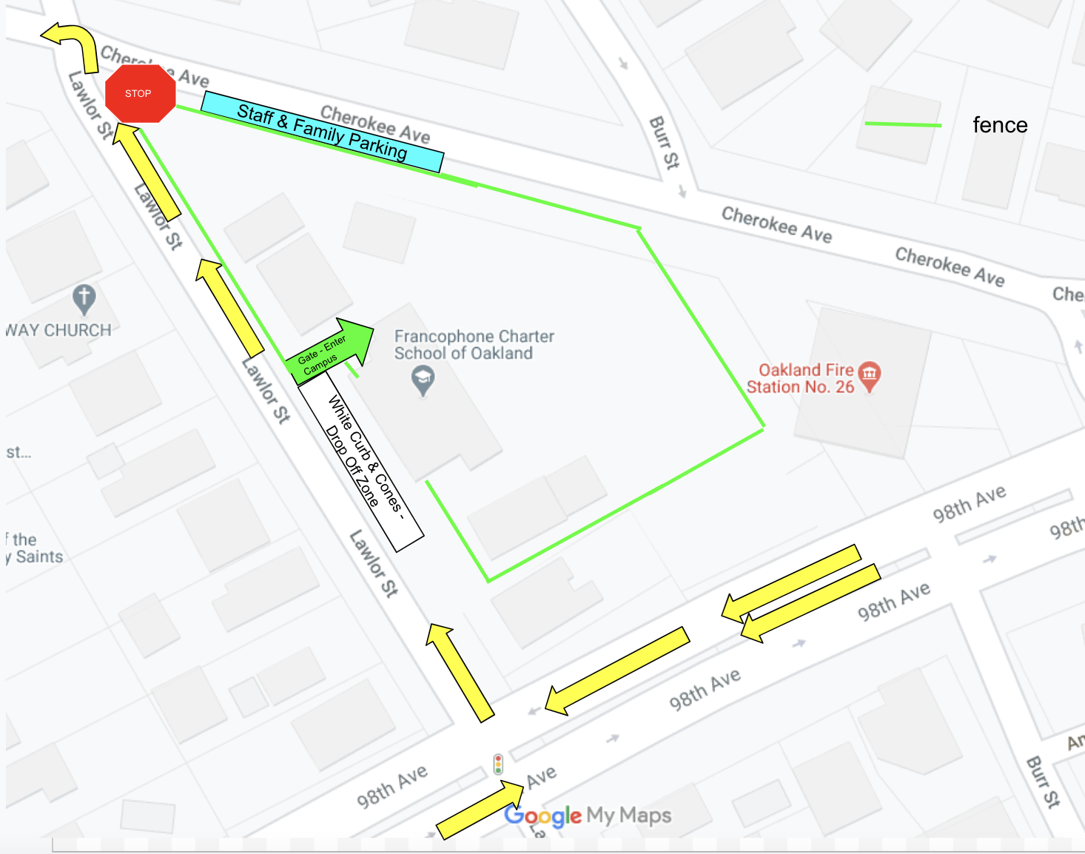

Rolling Drop-Off Procedures: Toler Campus (Morning Only)

- Rolling Drop-Off is open and available to families between 8:45am – 9:00am. Before and after this time period gates will be locked and families must use Francophone’s Park and Walk Procedures.
- Vehicles are to enter the Toler Heights campus drop-off zone by turning off of 98th Avenue onto Lawlor Street towards the school.
- The drop-off zones will be clearly marked with cones and signs that must be followed at all times.
- The drop-off zone will allow for the unloading of a group of four cars at one time. Each space will be numbered (1-4) and marked by cones.
- When the drop-off zone is filled, cars are to wait in a line in the order of arrival.
- Students may NOT exit a vehicle until it has fully pulled into a numbered spot in the drop-off zone and a volunteer or staff member has opened the car door.
- When directed by a staff member or volunteer, cars will pull into the drop-off zone in groups of four, with the front car pulling into the furthest spot (#1) and wait for a staff member or parent volunteer to open the car door, quickly take the child’s temperature and assist the student in quickly and safely exiting the vehicle.
- Students will then walk (not run) to report to the gate for check-in and hand sanitizer and directed to wash hands/ report to the classroom teacher.
- Vehicles will be unloaded from the front of the drop-off zone back (#1 first).
- After students have unloaded from the vehicles, and a staff member or volunteer has safely closed the vehicle door, drivers are advised to always pull out of the drop off zone safely and with extra caution, maintaining a slow speed and making sure to check mirrors and blindspots prior to moving their vehicle.
- After safely pulling out of the drop off zone, drivers are to proceed on Lawlor, followed by a left on Cherokee and the next left onto Thermal. Thermal will intersect with 98th Avenue in a block.
- Drivers using Rolling Drop-Off may not leave their vehicles, block neighbor driveways, nor make u-turns within a 3-block radius of the campus.
- The gates to the Rolling Drop-Off Zone will be closed and locked promptly at 9:00am.
- Students are only to be dropped off in the Drop-Off zone. If the Drop-Off zone is not available, drivers must use Francophone’s Park and Walk Procedures.

Park and Walk Procedures: Toler Heights Campus (Morning Arrival and Afternoon Dismissal)

- Drivers may use the Park and Walk Procedures at all times and/or when the AM Drop-Off Zone is not operating.
- If your child is late to school for any reason, please use the Park and Walk Procedures to escort them into the office and ensure they are checked into the care of the school staff and a reason for the late arrival is documented with the office by the responsible guardian.
- Drivers may carefully park in the parking lot located on Cherokee Street or in any legal and available parking space surrounding the Toler campus, with the exception of the non-school side of Lawlor Avenue. When parking, please avoid blocking the driveways of our neighbors at ALL times.
- Students in all grades must be accompanied by an adult or designated person to and from the Toler Heights Campus.
- When crossing streets, students and parents are to use designated crosswalks at all times.
- Students and parents are to enter and exit the Toler campus through the gate on Lawlor Street next to the marquee. When this gate is closed, students and parents are to enter the Toler campus by ringing the bell at the front double doors and by checking into the office. They are then to exit the building through the front double doors.
- When pulling away from a parking spot, drivers are advised to check mirrors and blindspots prior to moving their vehicle. Drivers should proceed with extra caution, maintaining a slow speed. Drivers may not make u-turns within a 3-block radius of the campus.

End of School Day Student Release Procedures for Parents, Guardians, and Designated Adults

- During the abbreviated in-person programming, the student dismissal period at the Francophone Toler Campus is from 3:05 – 3:30pm.
- All Francophone students must have a current Dismissal Information Form from parents on file in the office that designates each students’ end of day release plan including to whom the student may be released. Single day special arrangements may be made by contacting the office. More permanent changes to these plans should be made in writing to the office.
- Teachers will retain end of day release information for each student on a clipboard and will keep daily records of student dismissal and release.
- During the dismissal period, teachers will supervise students until the student is called to meet their responsible guardian at the gate.
  - Students will be released only to parents/guardians or other authorized adults
  - No after-care will be provided at this time.
- In order to ensure a safe and orderly pick-up period, students must remain within 10 feet of their parent/guardian or other authorized adults at all times and should make every effort to promptly exit campus.
- Site directors and teachers will be occupied monitoring safety procedures during pick up and drop off, and will be unavailable informal or formal conferencing during this time. Families encouraged to make appointments, email or use virtual office hours.
- Students who have not been picked up by the end of the dismissal period will be asked to call homie to be picked up. If this occurs three times, the family will be contacted and asked to determine a way to pick up on time or opt into distance learning.

Addendum #2

Mask guidance
Masks are a simple barrier to help prevent your respiratory droplets from reaching others. Studies show that masks reduce the spray of droplets when worn over the nose and mouth.

Some masks work better than others to help slow the spread of the virus that causes COVID-19. Note: N95 respirators approved by CDC’s National Institute for Occupational Safety and Health (NIOSH) should not be used outside of healthcare settings because they should be reserved for healthcare personnel.
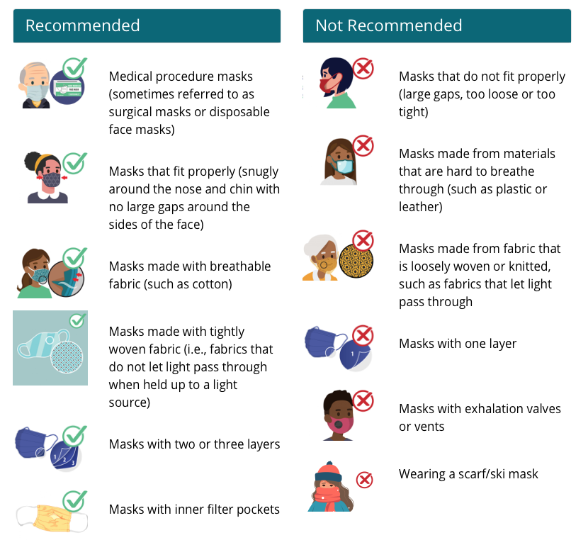
Source and for more information: COVID - 19 Guidance and Face Coverings

Addendum #3 -- To be done by parents at home before arriving at school
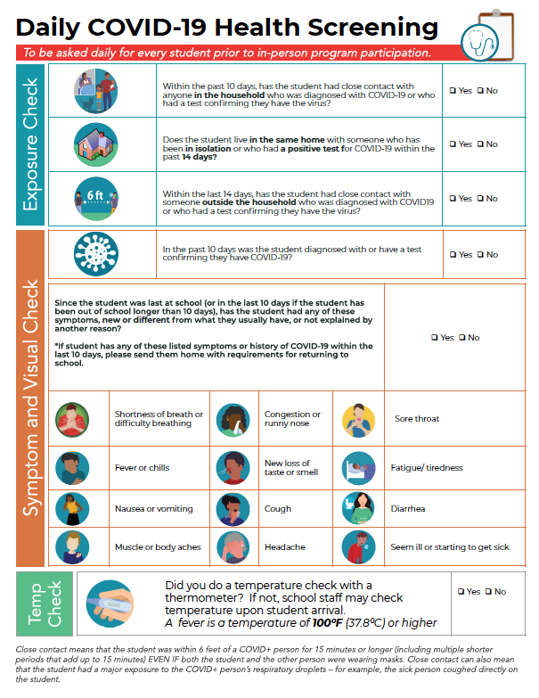

Addendum #4 -
What to do if there is a Confirmed or Suspected Case of COVID-19 in a School
What measures should be taken when a student, teacher or staff member has symptoms, is a contact of someone infected, or is diagnosed with COVID-19?
Table 2. Actions to take if there is a confirmed or suspected case of COVID-19 in a school
 | Student or Staff with: | Action | Communication with school community
1. | COVID-19 symptoms (e.g., fever, cough, loss of taste or smell, difficulty breathing) Symptom screening: per CDC Symptom of COVID-19. | - Send home if at school.  - Recommend testing (If positive, see #3, if negative, see #4).  - School/classroom remain open. | • No action needed.
2. | Close contact (†) with a confirmed COVID-19 case. | - Send home if at school.  - Exclude from school for 10 days from last exposure, per CDPH quarantine recommendations.  - Recommend testing 5-7 days from last exposure (but will not shorten 10-day exclusion if negative).  - School/classroom remain open. | • Consider school community notification of a known exposure. No action needed if exposure did not happen in school setting.
3. | Confirmed COVID- 19 case infection. | - Notify the LHD.  - Exclude from school for 10 days from symptom onset date or, if asymptomatic,  for 10 days from specimen collection date.  - Identify school contacts (†), inform the LHD of identified contacts, and exclude contacts (possibly the entire stable group (††)) from school for 10 days after the last date the case was present at school while infectious.  - Recommend testing asymptomatic contacts 5-7 days from last exposure and immediate testing of symptomatic contacts (negative test results will not shorten 10-day exclusion).  - Disinfection and cleaning of classroom and primary spaces where case spent significant time.  - School remains open. | - School community notification of a known case.  - Notification of persons with potential exposure if case was present in school while infectious
4. | Symptomatic  person tests negative or a healthcare provider has provided documentation that the symptoms are typical of their underlying chronic condition, or at least 10 days have passed since symptom onset | - May return to school after 24 hours have passed without fever and symptoms have started improving.  - School/classroom remain open. | • Consider school community notification if prior awareness of testing.

(†) A contact is defined as a person who is within 6 feet from a case for more than 15 minutes cumulative within a 24-hour period, regardless of face coverings. In some school situations, it may be difficult to determine whether individuals have met this criterion and an entire stable group, classroom, or other group may need to be considered exposed, particularly if people have spent time together indoors.
(††) See Stable Group Guidance for definition of a stable group. In some situations, (e.g., when seating charts are used, face covering is well adhered to, and teachers or staff have observed students adequately throughout the day), contact tracing and investigation may be able to determine more precisely whether each stable group member has been exposed. In this situation, those who were not close contacts could continue with in-person instruction.

Addendum #5: Sample Notification – School exposure to a case of COVID-19 notification
TK-12 SCHOOL NAME/LETTERHEAD
From School Principal (or Designee)
Date
Dear Parents/Guardians,
We would like to inform you that we have been notified about a confirmed case of COVID-19 (Coronavirus Disease 2019) in a member of our school community. The individual who tested positive (the “case”) was last on school premises on [DATE]. All school areas where the case spent time will be cleaned and disinfected before they are in use again.
Our school is working with the [LOCAL HEALTH DEPARTMENT] to follow up with the case and will reach out to all persons who are identified as having had close contact with the case to recommend home quarantine and COVID-19 testing. If you or your child are not contacted, it means that you or your child were not identified as exposed to the case.
Please remind your child to use their face covering, stay at least 6 feet from other people, and wash their hands often with soap and water for at least 20 seconds.
Symptoms of COVID-19 may appear 2-14 days after exposure to the virus and include:
  - Fever or chills
  - Cough
  - Shortness of breath or difficulty breathing
  - Fatigue
  - Muscle or body aches
  - Headache
  - New loss of taste or smell
  - Sore throat
  - Congestion or runny nose
  - Nausea or vomiting
  - Diarrhea
Anyone with COVID-19 symptoms should be tested. However, many infected people do not develop symptoms, which is why it is recommended that exposed people be tested whether they have symptoms or not.
Ensuring the health and safety of our students, teachers, and staff members is of the utmost importance to us. If you have any questions or concerns, please contact [CONTACT NAME] at XXX-XXX-XXXX.
Sincerely,
Addendum #6: Sample Notification – COVID-19 School Outbreak notification
TK-12 SCHOOL NAME/LETTERHEAD
From School Principal (or Designee)
Date

Dear Parents/Guardians, Teachers, and Staff Members,

We would like to inform you that we are working with the [LOCAL HEALTH DEPARTMENT] on their investigation of a COVID-19 outbreak in our school community. Our school is working with the [LOCAL HEALTH DEPARTMENT] to follow up with all cases and symptomatic contacts to identify all exposed persons and recommend home quarantine and testing. If you or your child are not contacted, it means that you or your child were not exposed to either a case or a symptomatic contact.

If you are a parent/guardian, please remind your child to use their face covering, stay at least 6 feet from other people, and wash their hands often with soap and water for at least 20 seconds.
Symptoms of COVID-19 may appear 2-14 days after exposure to the virus and include:

  - Fever or chills
  - Cough
  - Shortness of breath or difficulty breathing
  - Fatigue
  - Muscle or body aches
  - Headache
  - New loss of taste or smell
  - Sore throat
  - Congestion or runny nose
  - Nausea or vomiting
  - Diarrhea

Anyone with COVID-19 symptoms should be tested. However, many infected people do not develop symptoms, which is why it is recommended that exposed people be tested whether they have symptoms or not.

Ensuring the health and safety of our students, teachers, and staff members is of the utmost importance to us. If you have any questions or concerns, please contact [CONTACT NAME] at XXX-XXX-XXXX.

Sincerely,

Addendum #7: Sample Notification – School closure due to COVID-19 notification
TK-12 SCHOOL NAME/LETTERHEAD
Dear Parents/Guardians, Teachers, and Staff Members,
We are informing you that we are closing our school, starting on [DATE] due to the ongoing COVID-19 outbreak and likely continuing transmission at our school. In consultation with the [LOCAL HEALTH OFFICER], we have been advised that the school should be closed for 14 days to prevent further transmission of COVID- 19 and to clean and disinfect the school before reopening on [DATE].
During school closure, the school will switch to online teaching to continue our classes; please see attached information sheet on how students can sign in to continue their schoolwork online. The [LOCAL HEALTH DEPARTMENT] will also continue to follow-up with cases and contacts during school closure to ensure isolation and quarantine and testing.
If upon school reopening, your child is feeling ill or having a fever or symptoms of COVID-19, even if symptoms are very minor, please do not send your child to school and consider getting your ill child tested for COVID-19. If your child is well without any symptoms, please remind your child before going back to school to use their face covering, stay at least 6 feet from other people, and wash their hands often with soap and water for at least 20 seconds. School staff should call in sick and stay home if having a fever or symptoms of COVID-19 and consider getting tested.
Symptoms of COVID-19 may appear 2-14 days after exposure to the virus and include:
  - Fever or chills
  - Cough
  - Shortness of breath or difficulty breathing
  - Fatigue
  - Muscle or body aches
  - Headache
  - New loss of taste or smell
  - Sore throat
  - Congestion or runny nose
  - Nausea or vomiting
  - Diarrhea
Ensuring the health and safety of our students, teachers, and staff members is of the utmost importance to us. If you have any questions or concerns, please contact [CONTACT NAME] at XXX-XXX-XXXX.
Sincerely,
Please complete the following Survey to confirm that you have read the School Reopening Plans - COVID and that you agree to comply with the protocols stated here and that you will do a DAILY health screening with your student prior to arrival at school.

